**Design Patterns**

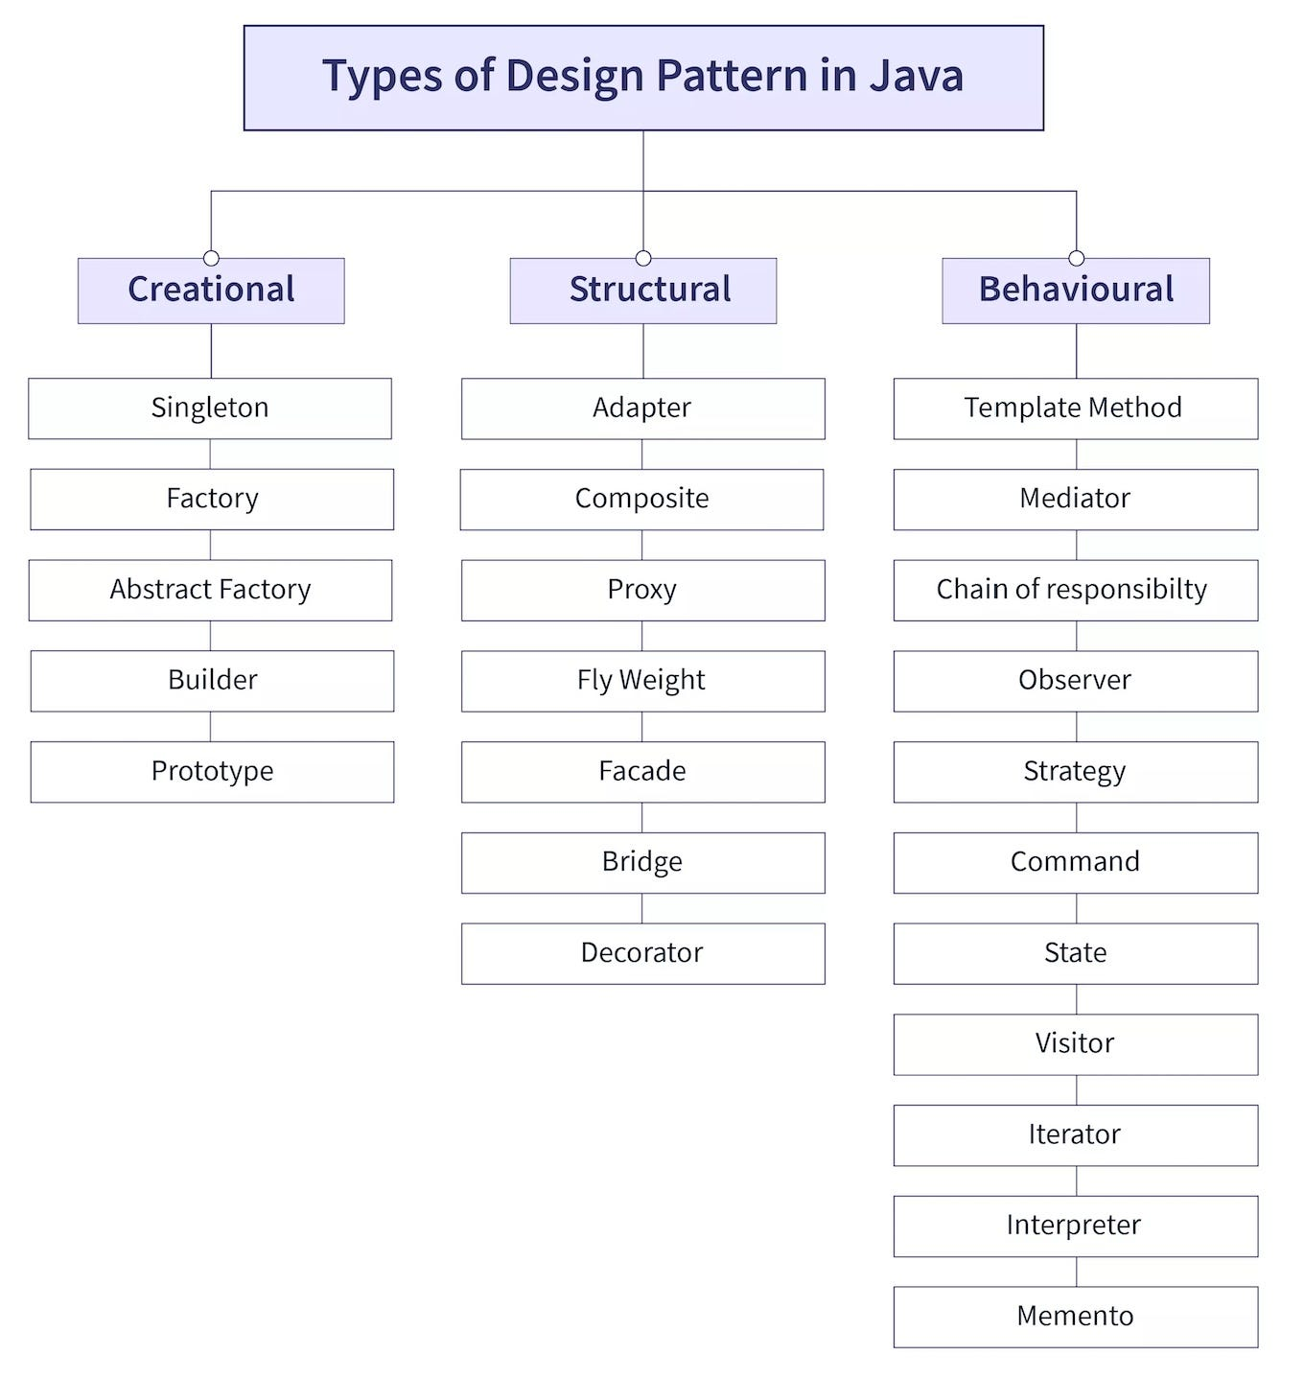

**Structural**

**Adapter Design Pattern**

Adapter Design pattern state that one object is compatible with other objects.

In simple word Adapter means it will provide the interface to work incompatible objects with each other.

For example

If we have app work with XML data

Now in future we have other app but in this app have work with only JSON data.

Now we need to create an interface which will work like Adaptor.